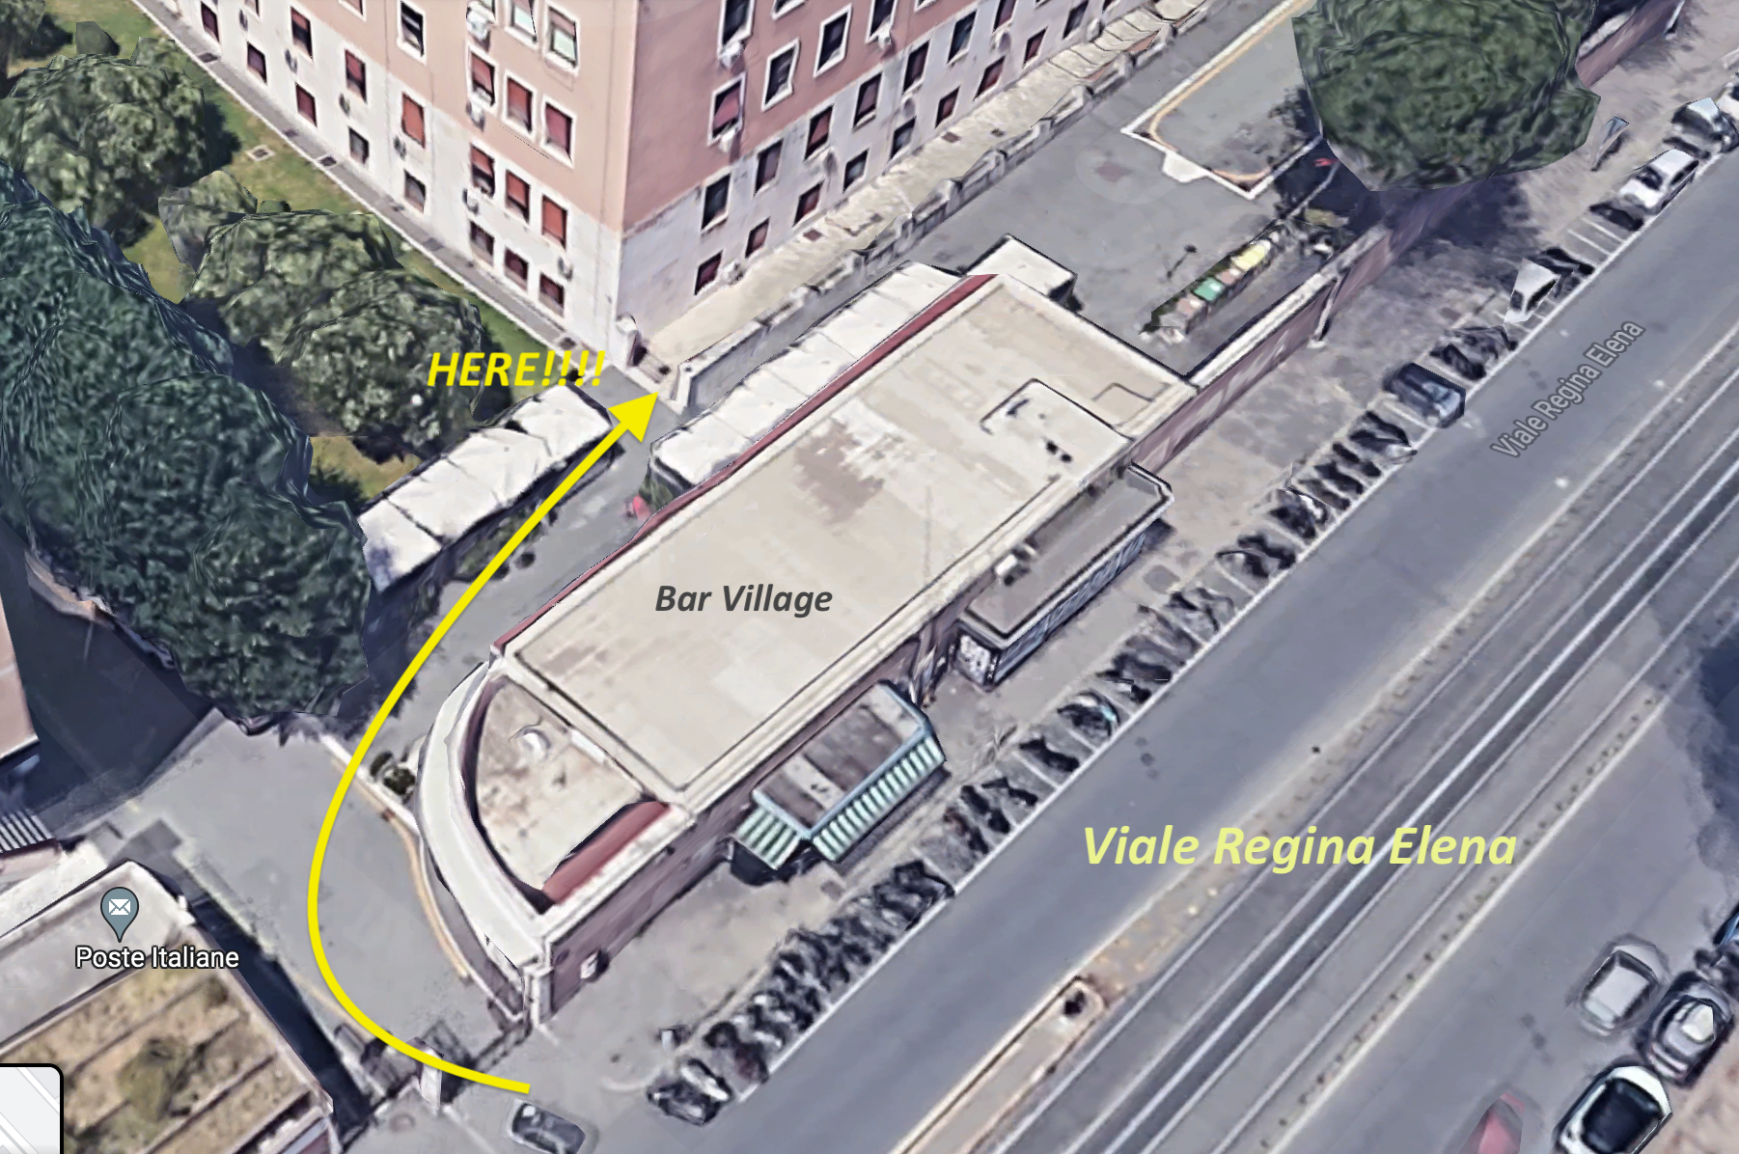

To reach the classroom please enter the brown gate in front of the café of the Viale Regina Elena main entrance, walk through the path and enter the door where there is written Aula Psicologia on the top.