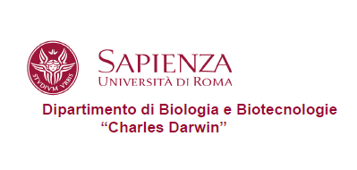
Aula Psicologia CU026

Mercoledì 20 Marzo 2019
Ore 14

Enrico Domenici
CIBIO Centre for Integrative Biology - University of Trento
Coordinator of the Master of Science (Laurea Magistrale) in Quantitative and Computational Biology

Studying Quantitative and Computational Biology: requirements, perspectives and professional opportunities.

